

BACHELOR OF SCIENCE IN COMPUTER SCIENCE

ADVANCED WEB DESIGN AND DEVELOPMENT

BIT3208

Mr. NYORO MICHAEL

YEAR 3

NAME: ASHLEY JOY ONYANGO

ADM NO: BSCCS/2024/50264

PROJECT TITLE: INVENTORY MANAGEMENT SYSTEM

SELECTED TECHNOLOGIES
• PHP + MySQL
• HTML
• CSS
• JavaScript
• XAMPP
• GitHub
• Canva

GIT HUB LINK: https://github.com/xoashlyyy/advanced_web_design

Contents
Week 1: Local Environment Setup 3
Week 2: Wireframes and GUI Design 5
Week 3: JavaScript and PHP Basics 8
Week 4: Server-Side Components and Backend Development 11
Week 5: Database Components and CRUD Operations 13
WEEK 6 19
Practical Task 1: Student Management System 19
Practical Task 2: Library Book Management System 24
Practical Task 3 (Challenge Task): Employee Records Management System 25

Table of figures
Figure 1: Git and XAAMP installation 3
Figure 2: Apache & MySQL running 4
Figure 3: Hello World test 4
Figure 4: Database connection PHP script 5
Figure 5: DB connection confirmation 5
Figure 6: Wireframe 6
Figure 7: Dashboard layout design 6
Figure 8: Mobile view mockup 7
Figure 9: Colour theme 7
Figure 10: Navigation structure 8
Figure 11: GUI Figma prototype 8
Figure 12: Database creation 9
Figure 13: JS form validation 9
Figure 14: Password strength checker 10
Figure 15: Database connection script 10
Figure 16: Dynamic User Input Handling 10
Figure 17: Database creation 11
Figure 18: Form Validation 11
Figure 19: Successful Registration 12
Figure 20: Login form 12
Figure 21: Login successful 12
Figure 22: Database and tables creation 13
Figure 23: Create script 14
Figure 24: Updated table after create 14
Figure 25: Update script 15
Figure 26:Delete script 16
Figure 27: Read script(dashboard) 17
Figure 28: Dashboard (Read) UI 17
Figure 29: Sign in UI 18
Figure 30: Update UI 18
Figure 31: Create UI 19
Figure 32: Database Creation 20
Figure 33: CRUD Operations 21
Figure 34: Student Management Portal Read 22
Figure 35:Student Management Portal Create 22
Figure 36: Student Management Portal Update 23
Figure 37: "Fadhili Wanyoike Nyoro" Deleted 23
Figure 38: Library Management System Create & Read 24
Figure 39: "Memory Man" Deleted 24
Figure 40: Library Management System Update 25
Figure 41:Employee Records Management System Login 26
Figure 42: "Fadhili Wanyoike" Deleted 26
Figure 43: Employee Records Management System Create & Read 27
Figure 44: Employee Records Management System 28
Figure 45: Search Employee 29
Figure 46: Form Validation 29

Week 1: Local Environment Setup
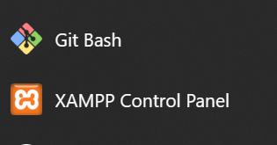
Figure 1: Git and XAAMP installation

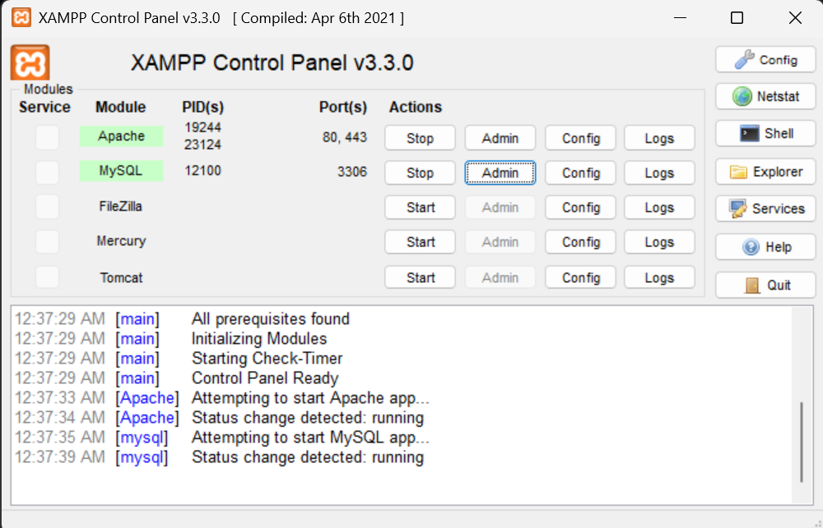
Figure 2: Apache & MySQL running
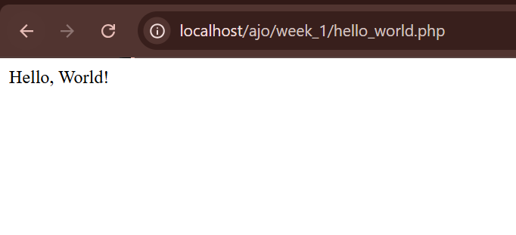
Figure 3: Hello World test
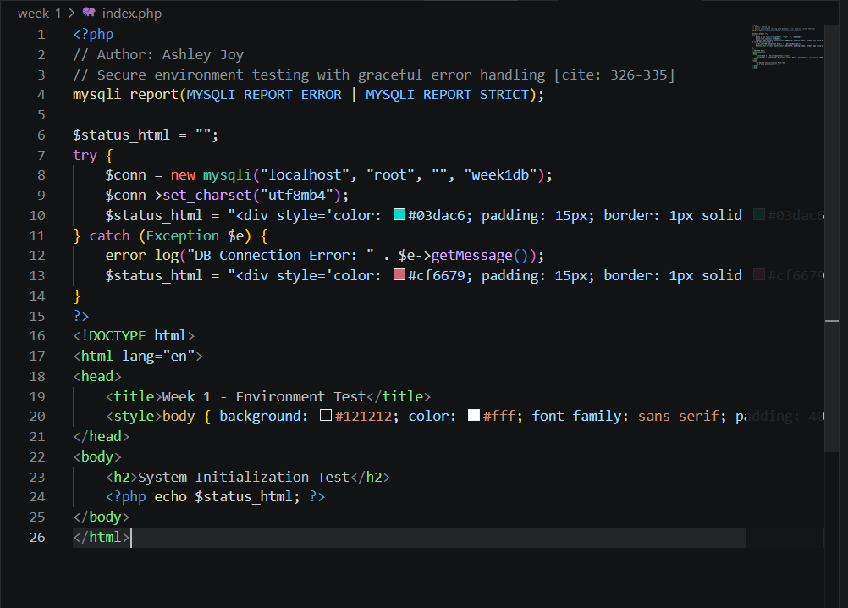
Figure 4: Database connection PHP script

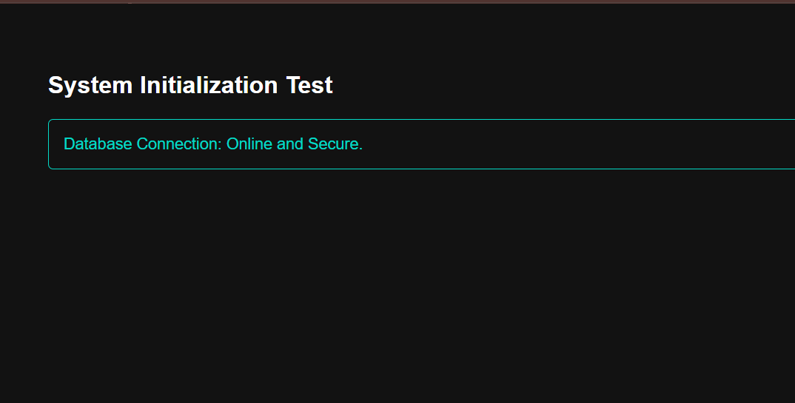
Figure 5: DB connection confirmation
This week, I learned to configure a local server environment using XAMPP and establish a secure backend connection. The screenshots demonstrate Apache and MySQL services running successfully, alongside a PHP script utilizing mysqli_report() for error handling to connect to the database. A minor challenge was ensuring the correct ports were unblocked so Apache could run smoothly. Ultimately, these screenshots confirm that the fundamental local environment is correctly configured and successfully executing PHP logic

Week 2: Wireframes and GUI Design
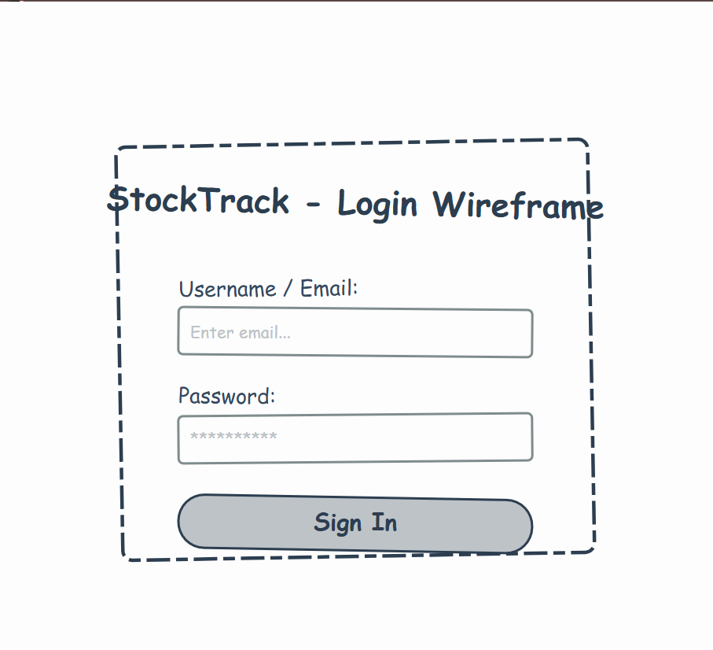
Figure 6: Wireframe
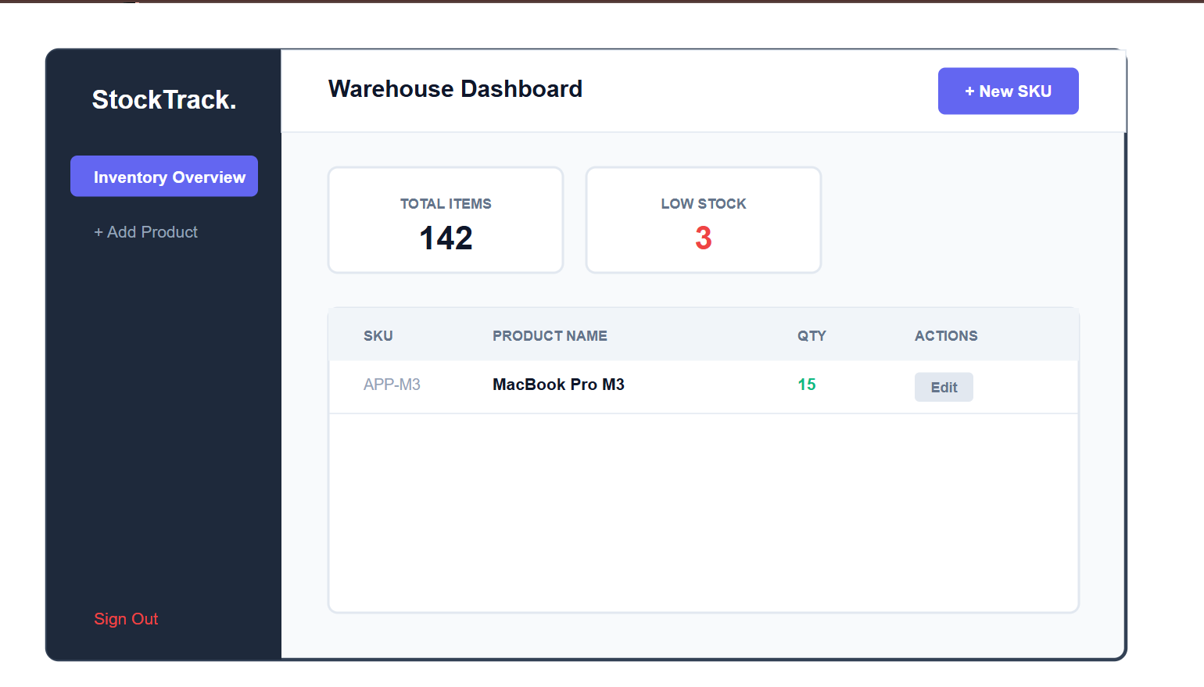
Figure 7: Dashboard layout design
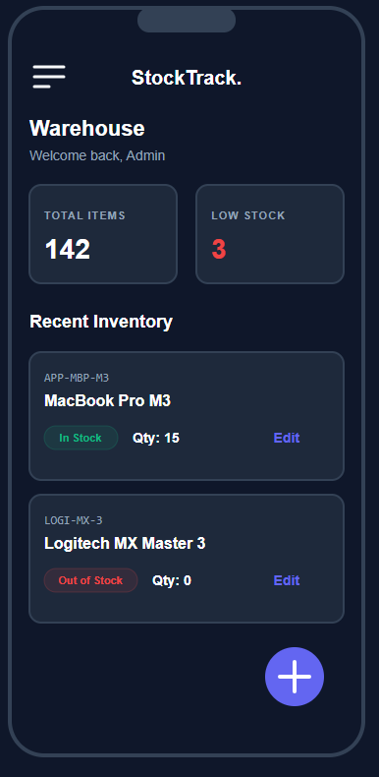
Figure 8: Mobile view mockup

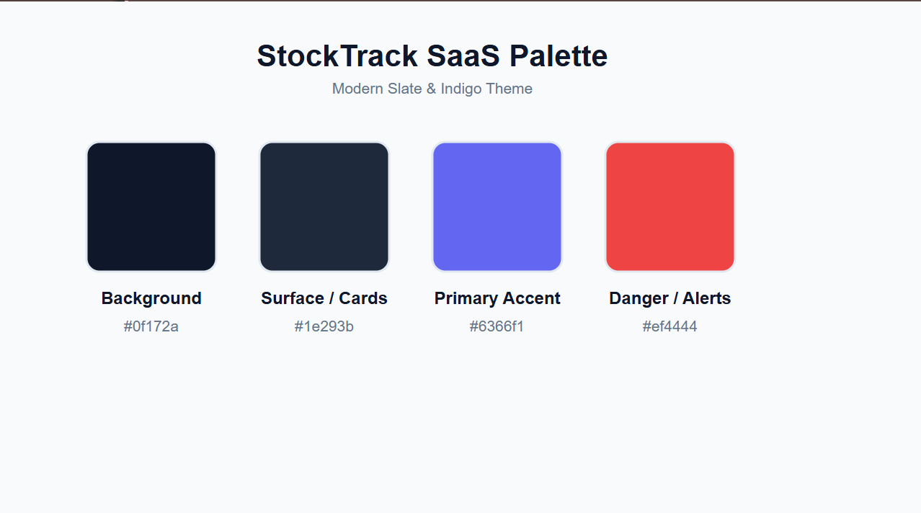
Figure 9: Colour theme
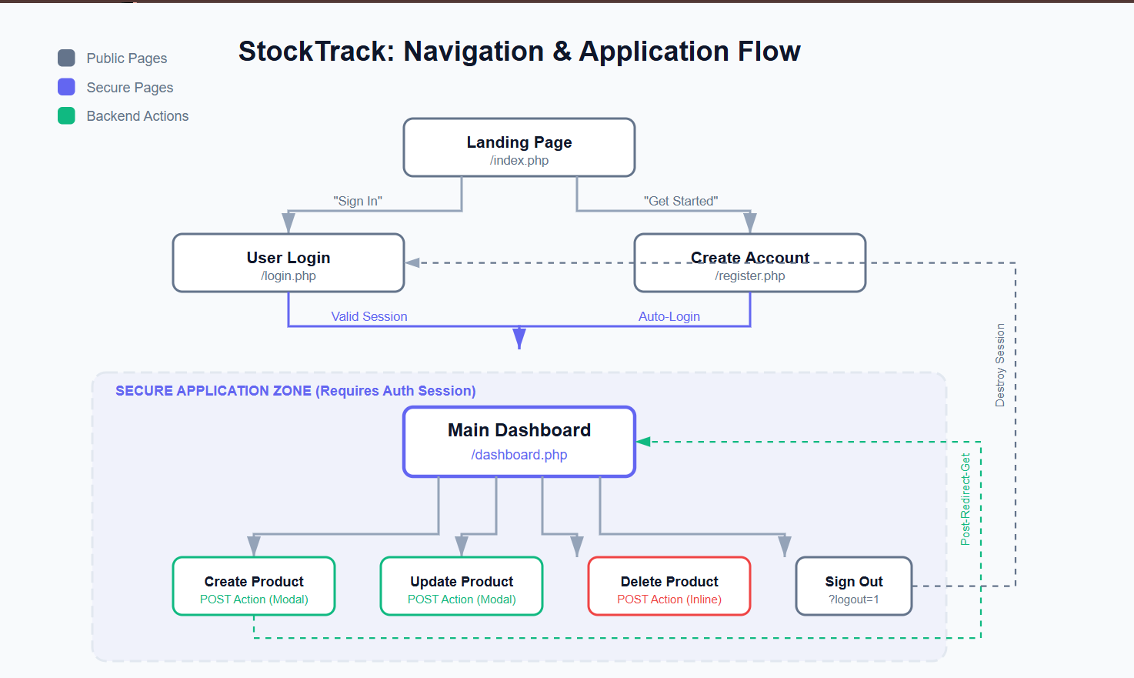
Figure 10: Navigation structure
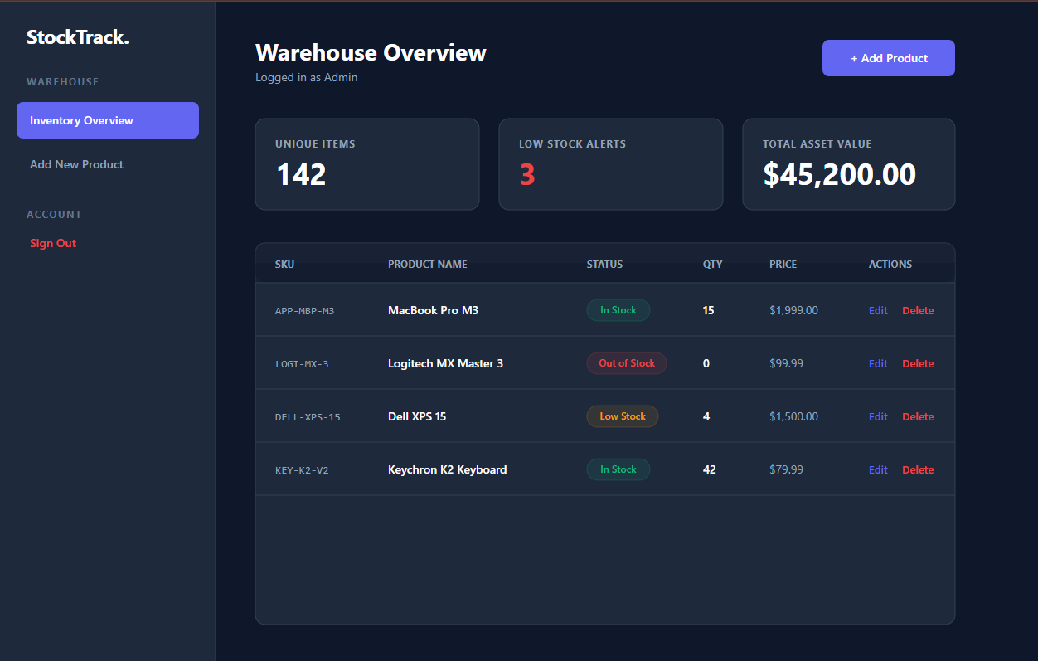
Figure 11: GUI Figma prototype

I focused on UI/UX principles to design an intuitive interface for the StockTrack inventory system. The screenshots illustrate the progression from low-fidelity wireframes to a high-fidelity Figma prototype, utilizing a modern slate and indigo color palette. I learned how to structure navigation flow to reduce user clicks for inventory management tasks. A challenge was adapting the dashboard layout for mobile views, which I resolved by designing a compact, card-based layout. These designs will serve as the exact blueprint for the frontend coding phase.

Week 3: JavaScript and PHP Basics
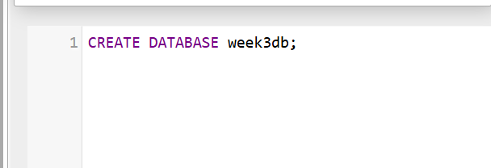
Figure 12: Database creation

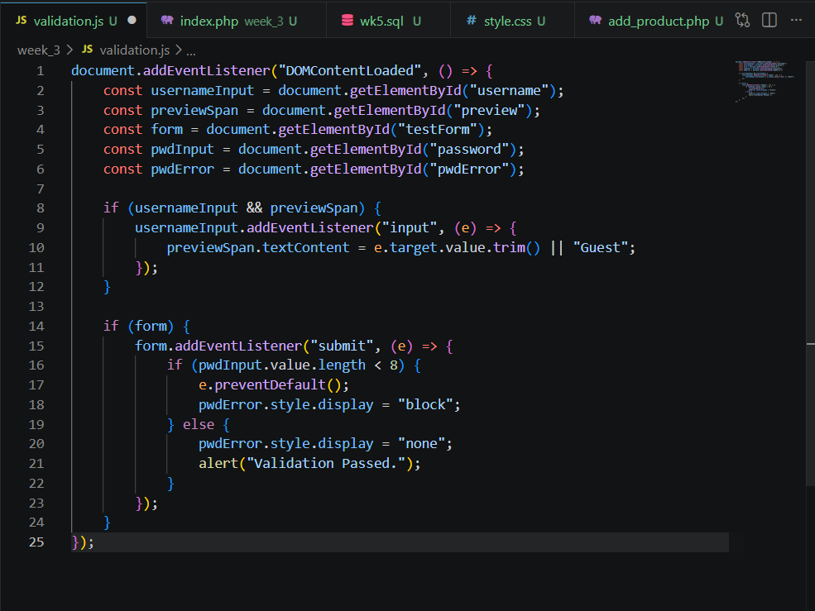
Figure 13: JS form validation

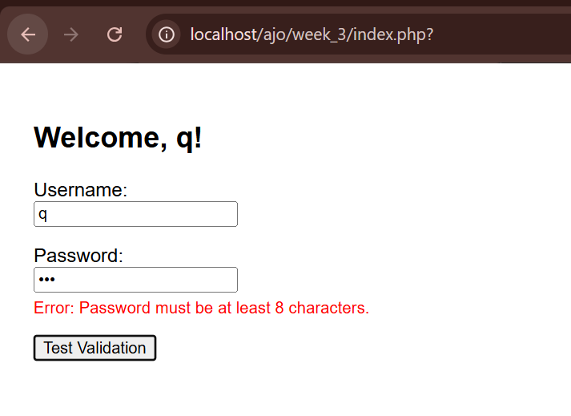
Figure 14: Password strength checker

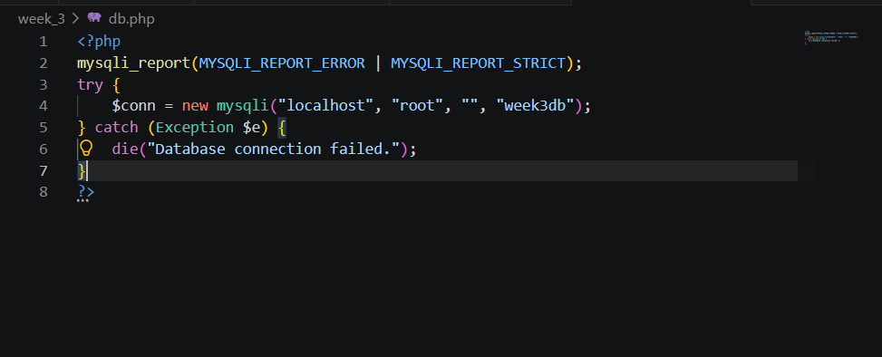
Figure 15: Database connection script
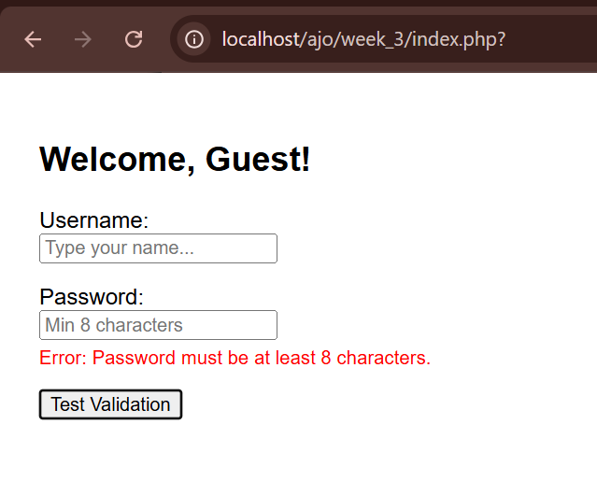
Figure 16: Dynamic User Input Handling
I learned how frontend validation interacts with backend foundations by building a dynamic login form. The screenshots show JavaScript preventing form submission if a password is under 8 characters and updating the DOM to display specific error messages. Additionally, I practiced PHP syntax to connect to the backend database securely. A challenge was ensuring real-time UI updates, which I solved by capturing the 'input' event to dynamically display the username. This client-side validation improves user experience by catching errors before reaching the server.

Week 4: Server-Side Components and Backend Development
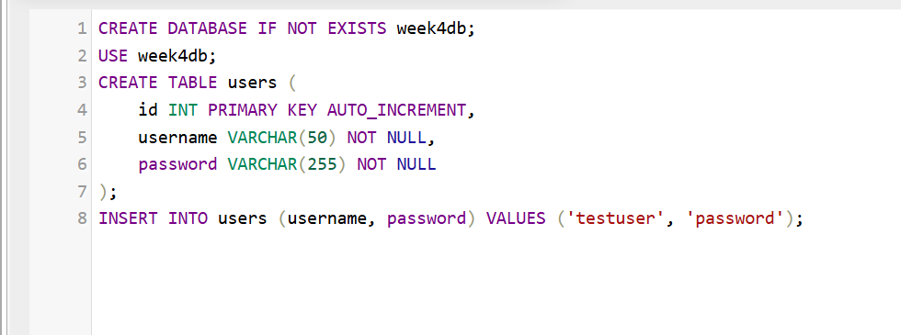
Figure 17: Database creation
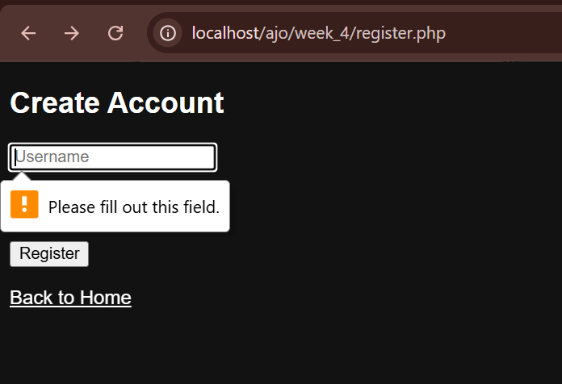
Figure 18: Form Validation

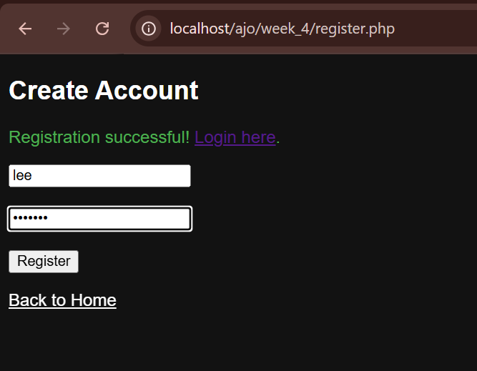
Figure 19: Successful Registration
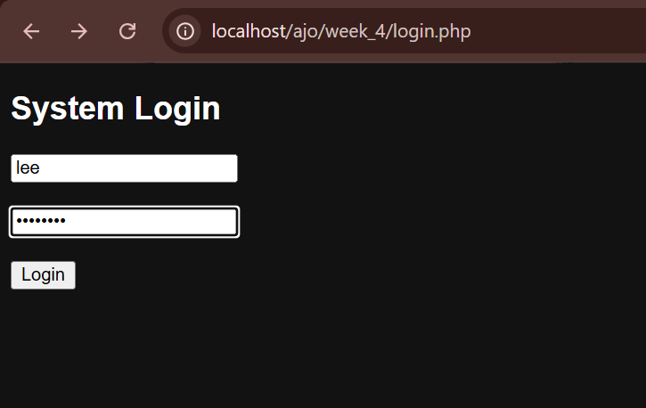
Figure 20: Login form
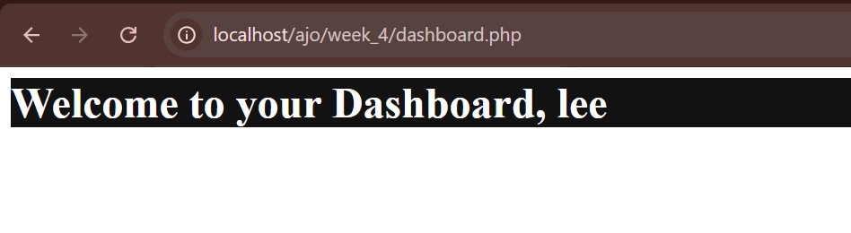
Figure 21: Login successful
I transitioned StockTrack from static pages to a dynamic system by implementing server-side processing with PHP. I learned how to handle HTTP POST requests securely for user registration and form submissions. The screenshots demonstrate a functional authentication system where user credentials are validated, successfully initiating a secure session upon login. A key challenge was structuring the project directories professionally, which I resolved by cleanly isolating backend logic into an 'includes' folder. These implementations establish the critical backend foundation for a secure, session-managed dashboard.

Week 5: Database Components and CRUD Operations
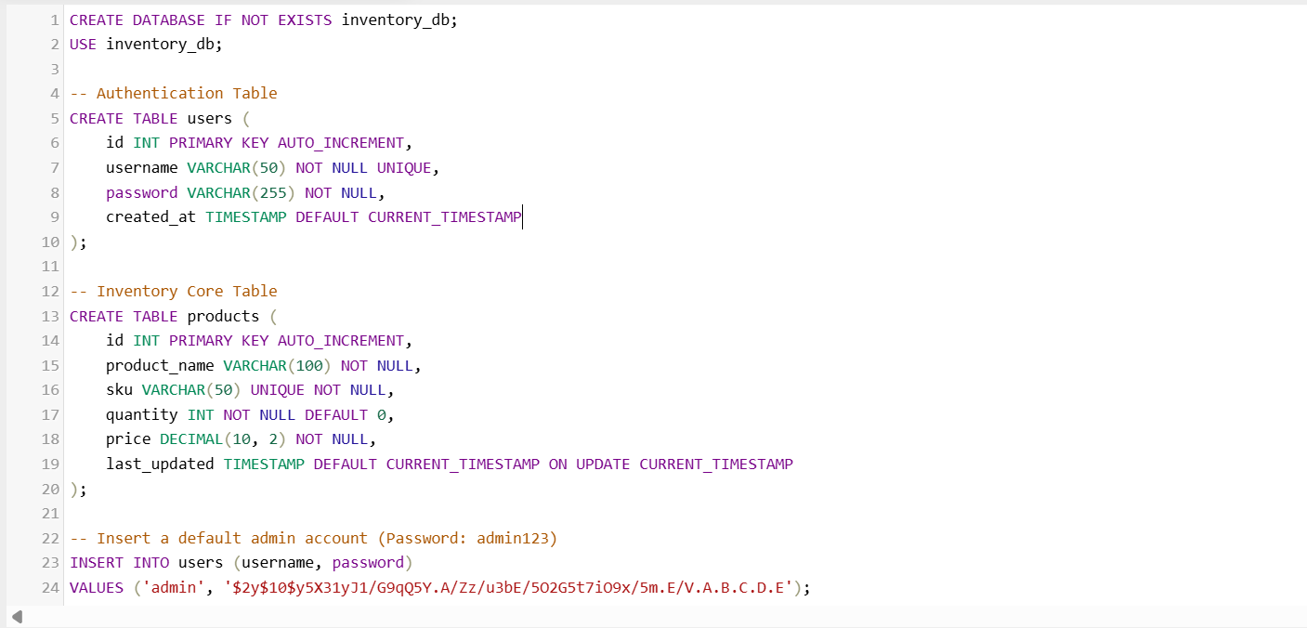
Figure 22: Database and tables creation

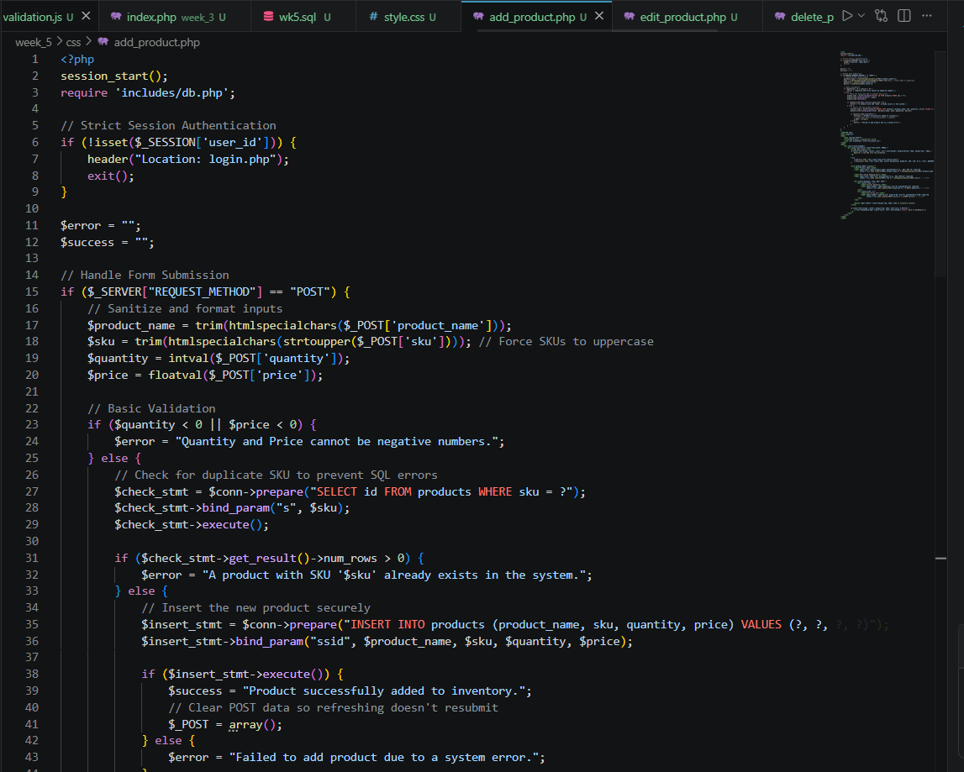
Figure 23: Create script
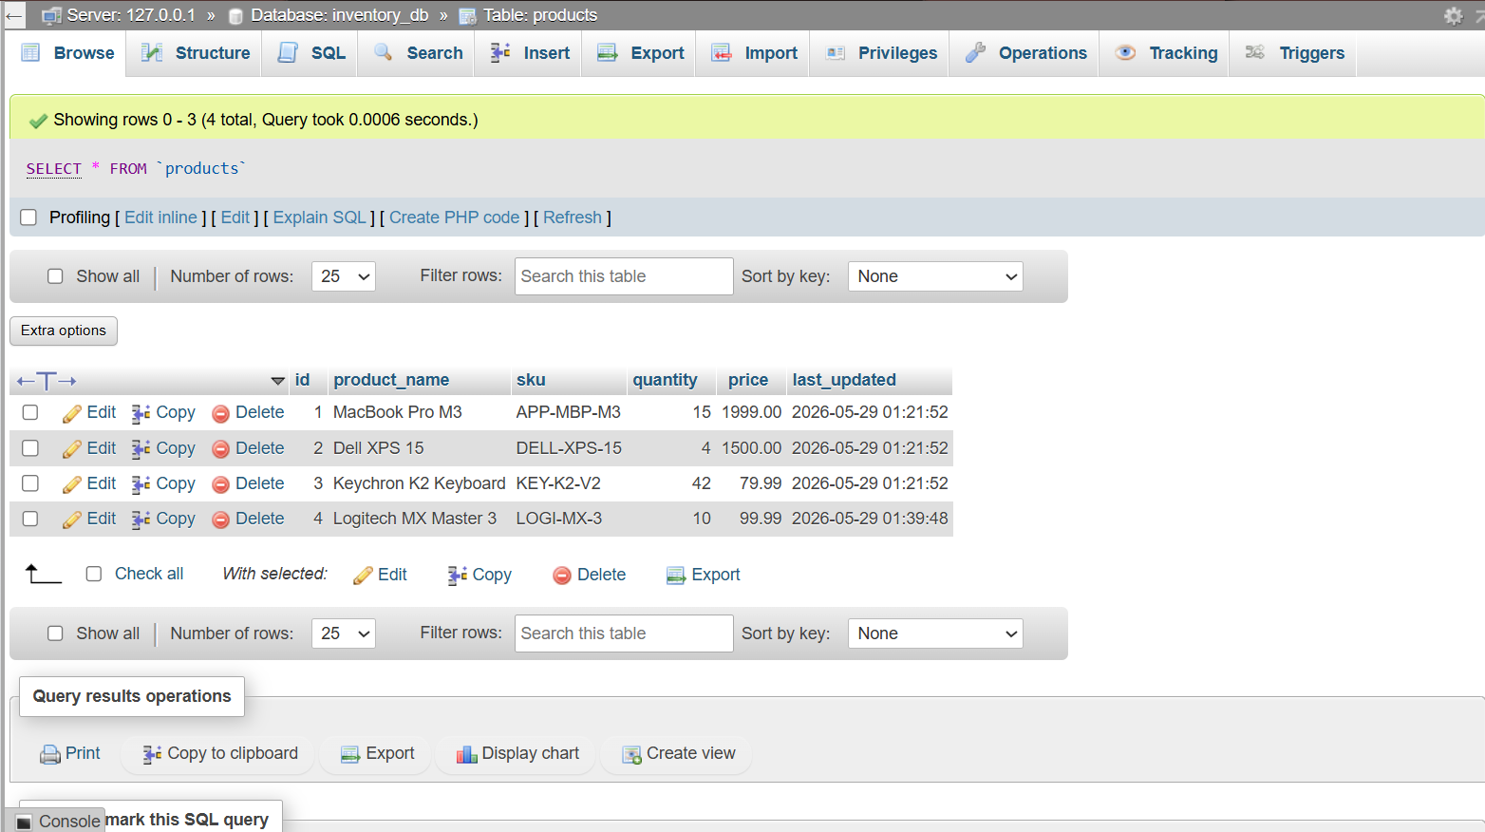
Figure 24: Updated table after create
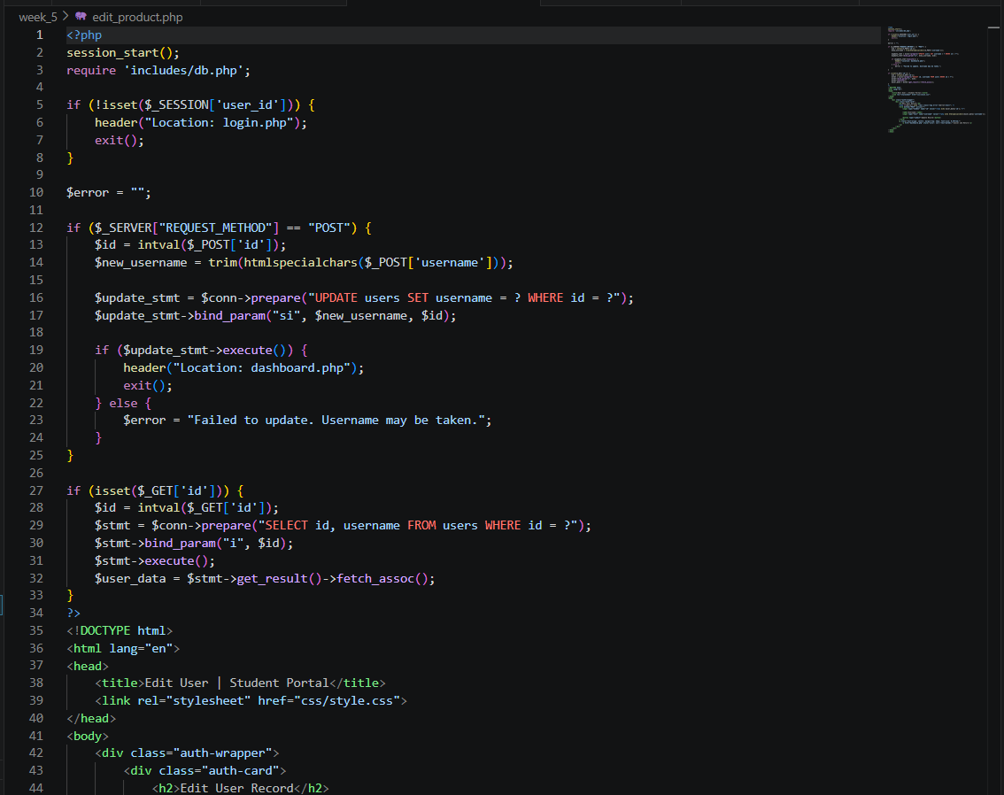
Figure 25: Update script
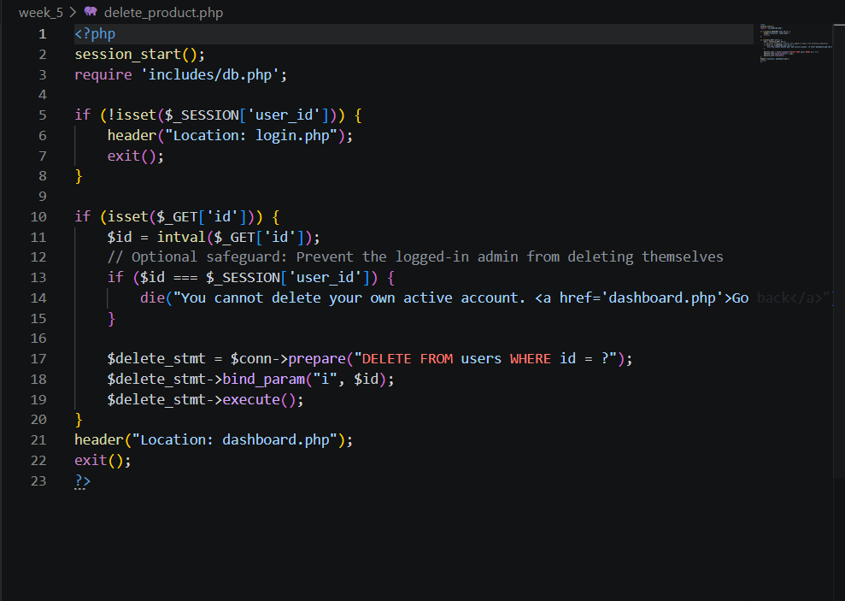
Figure 26:Delete script

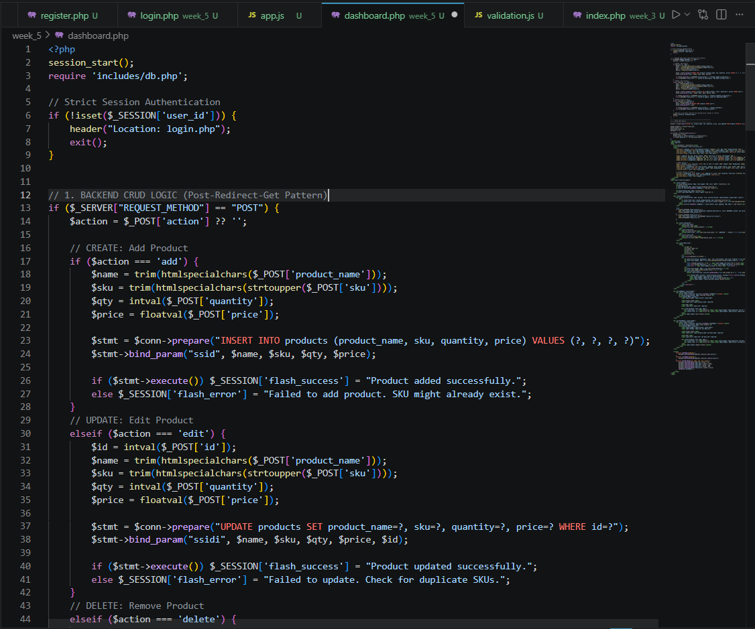
Figure 27: Read script(dashboard)
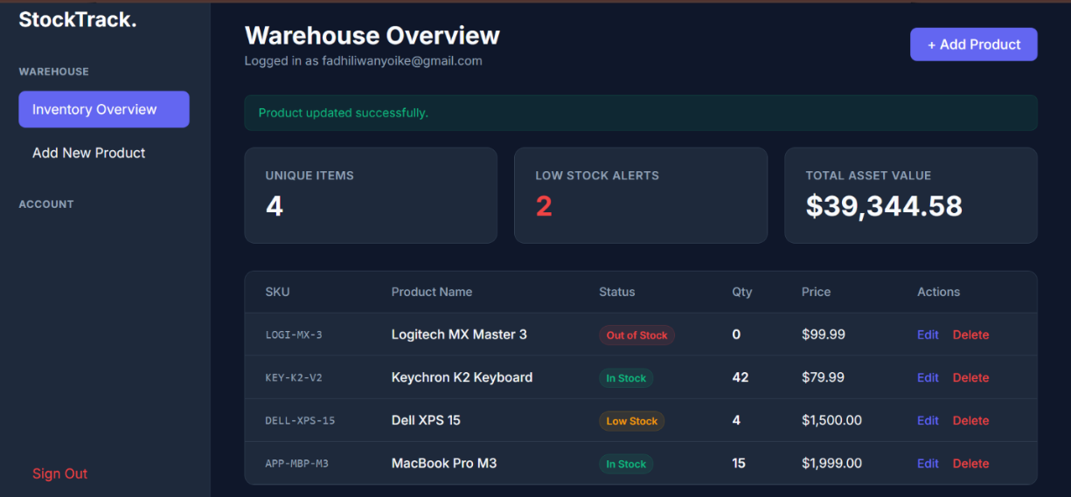
Figure 28: Dashboard (Read) UI
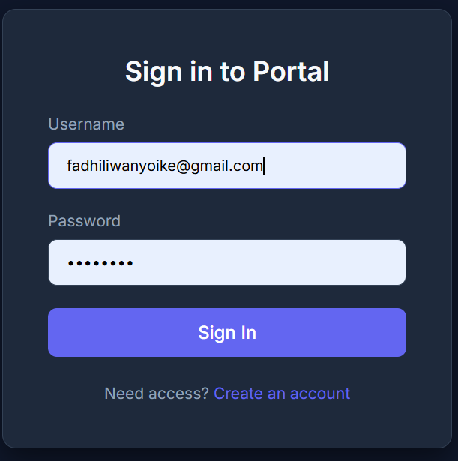
Figure 29: Sign in UI
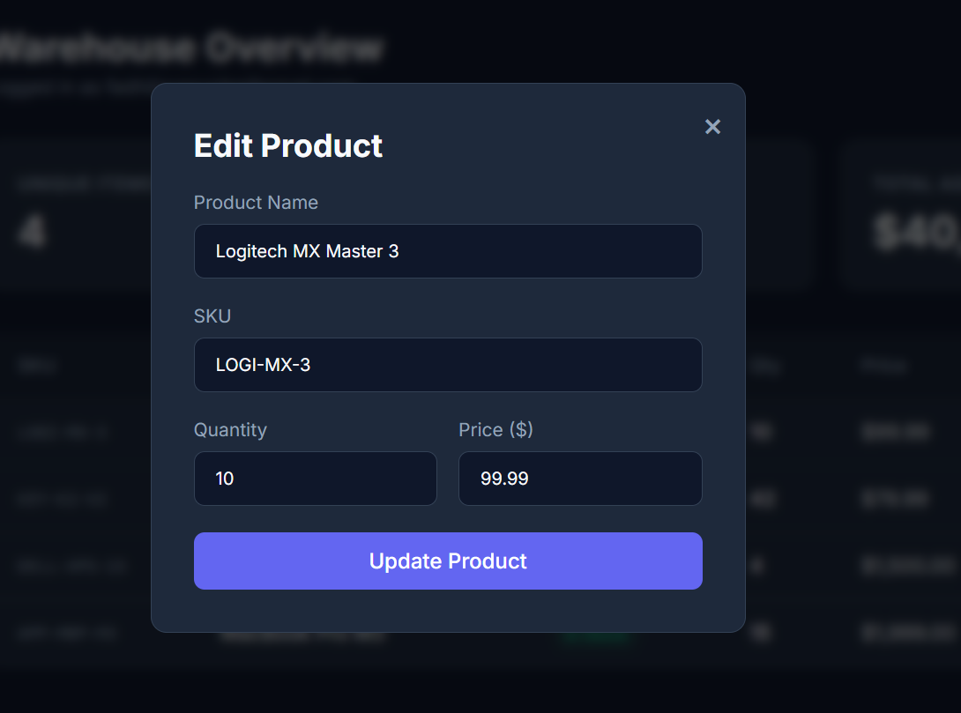
Figure 30: Update UI
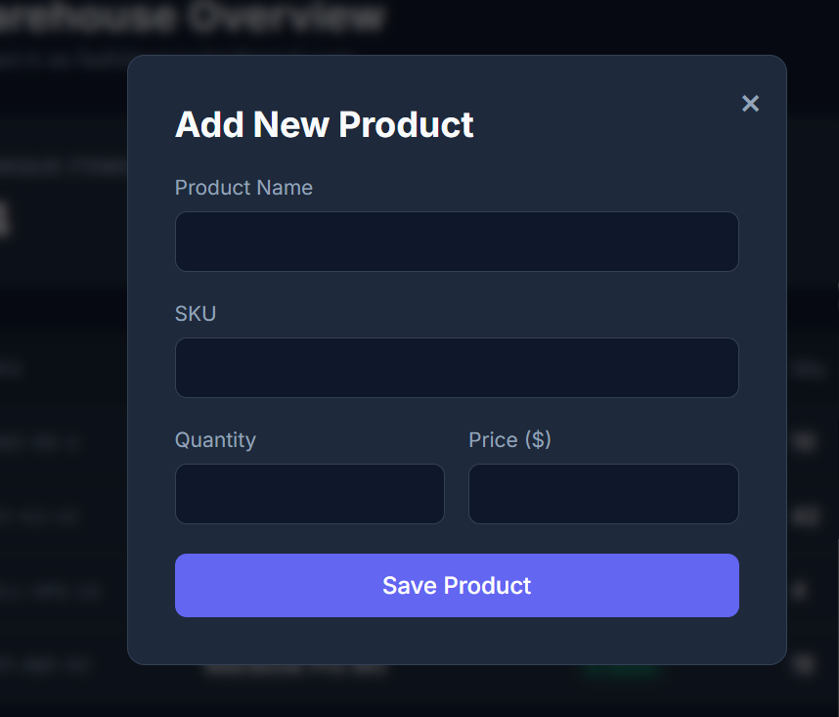
Figure 31: Create UI
I focused on integrating persistent data storage by connecting the PHP backend to a newly structured MySQL database. I learned to execute essential CRUD operations, enabling the system to securely add, view, update, and delete inventory records. The screenshots demonstrate successful database queries fetching and rendering live data directly onto the frontend dashboard. The main challenge was mitigating security risks during data insertion, which I handled by strictly implementing parameterized prepared statements. This successfully transforms the UI into a fully functional, data-driven platform.

WEEK 6

Practical Task 1: Student Management System
I developed a mini-Student Management System using PHP and MySQL. I successfully created a database table to store student records and built an HTML form to capture their full name, email, and course details. The application implements complete CRUD operations, allowing users to securely add new students to the database, view all registered students in a formatted table, edit existing student information through a dedicated update form, and delete records as needed.
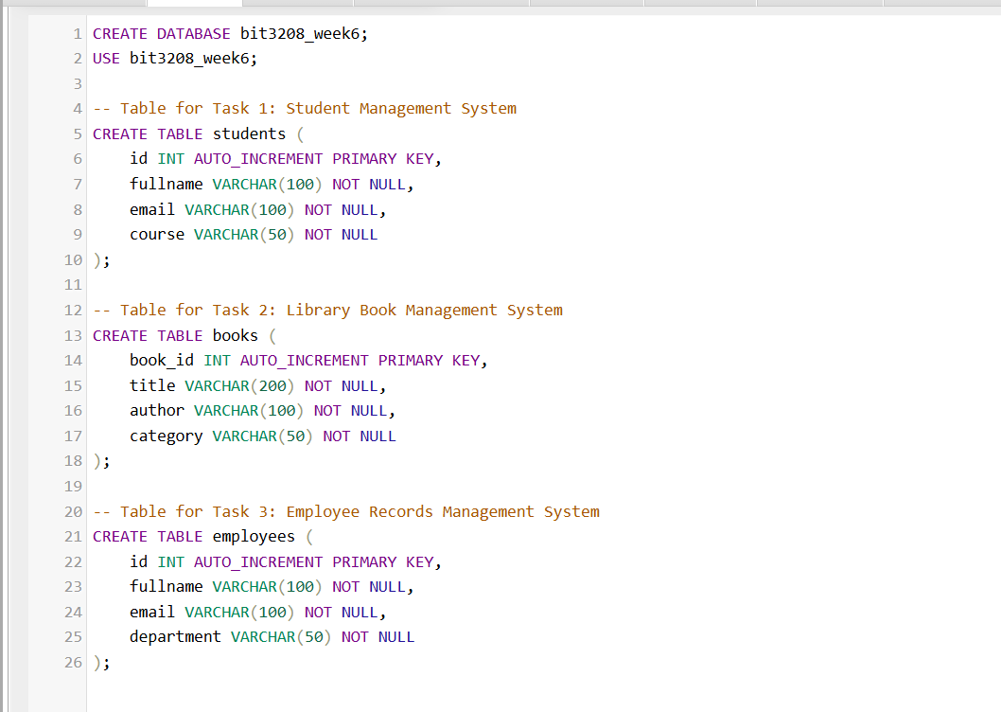
Figure 32: Database Creation
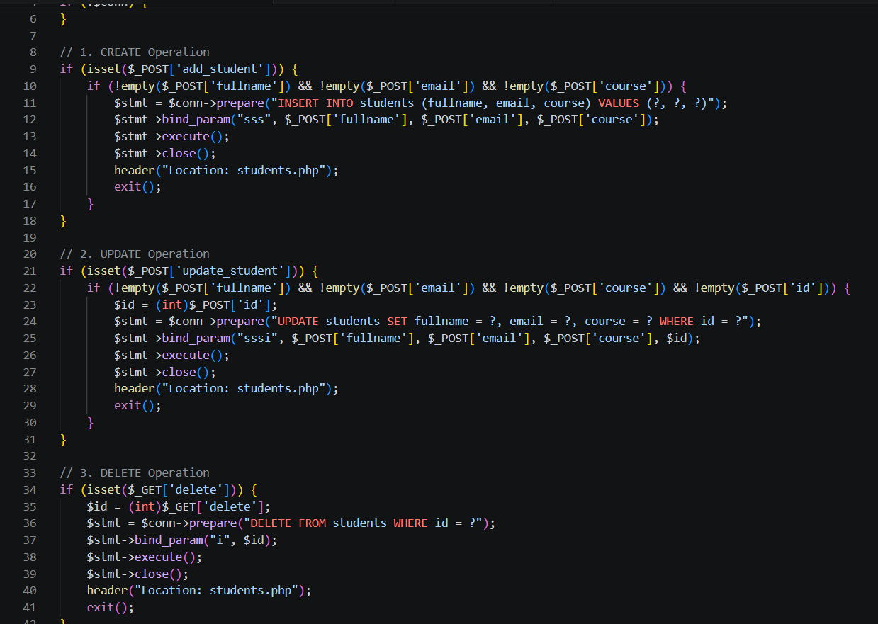
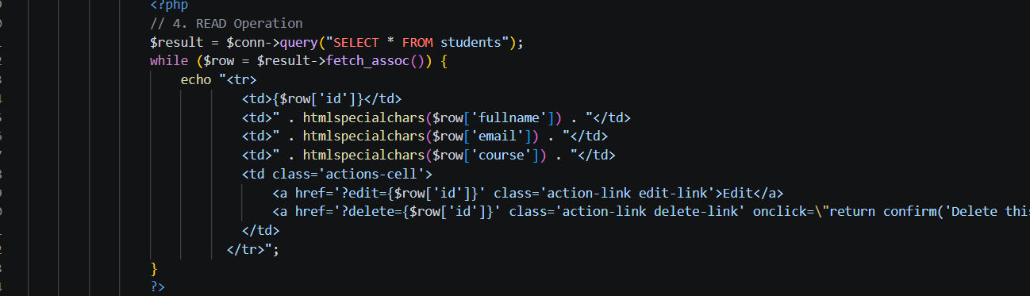
Figure 33: CRUD Operations

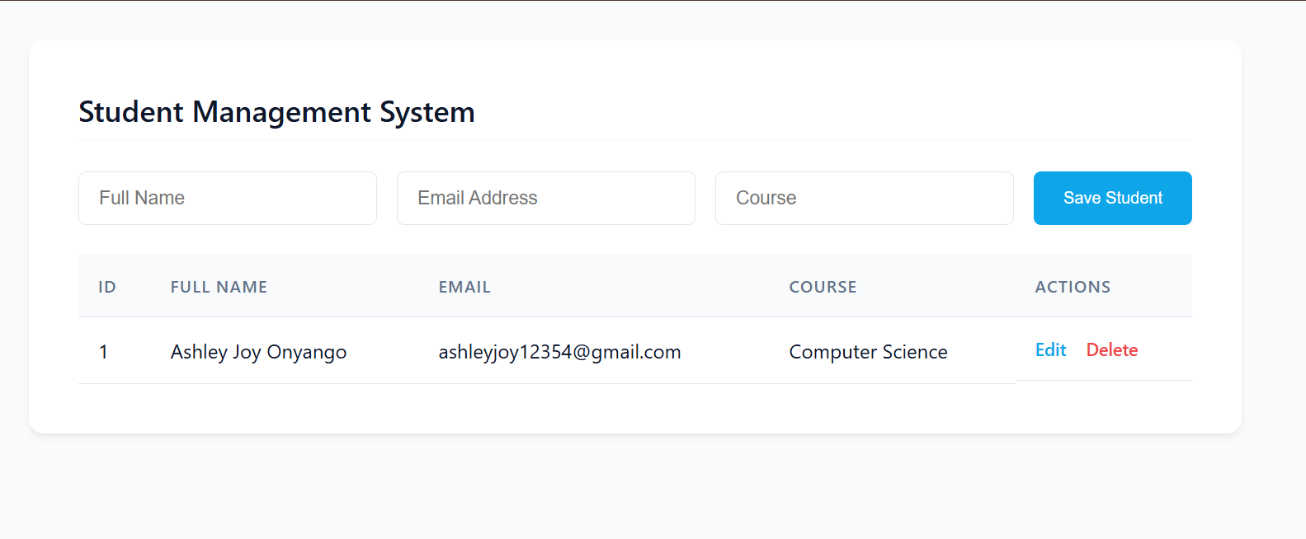
Figure 34: Student Management Portal Read

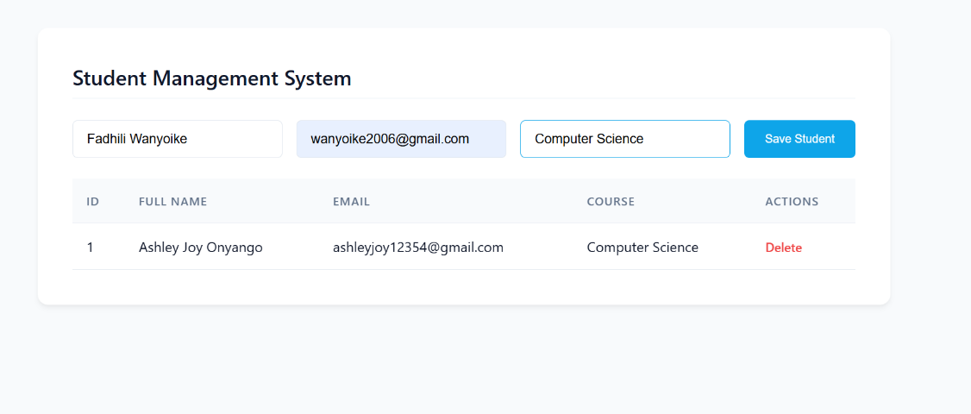
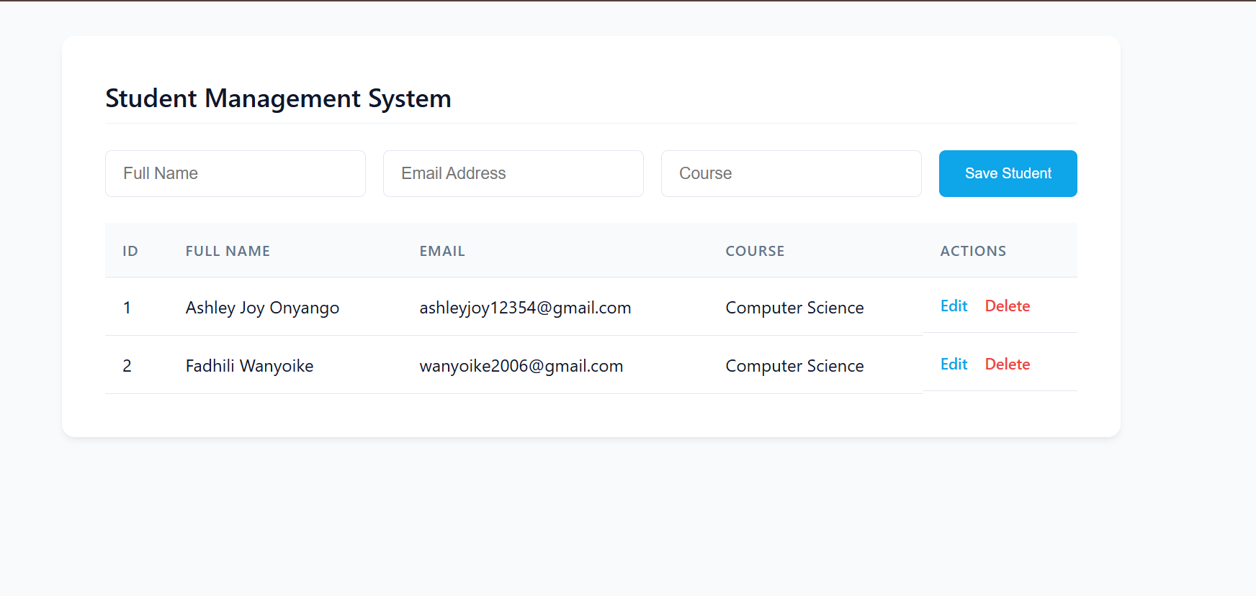
Figure 35:Student Management Portal Create

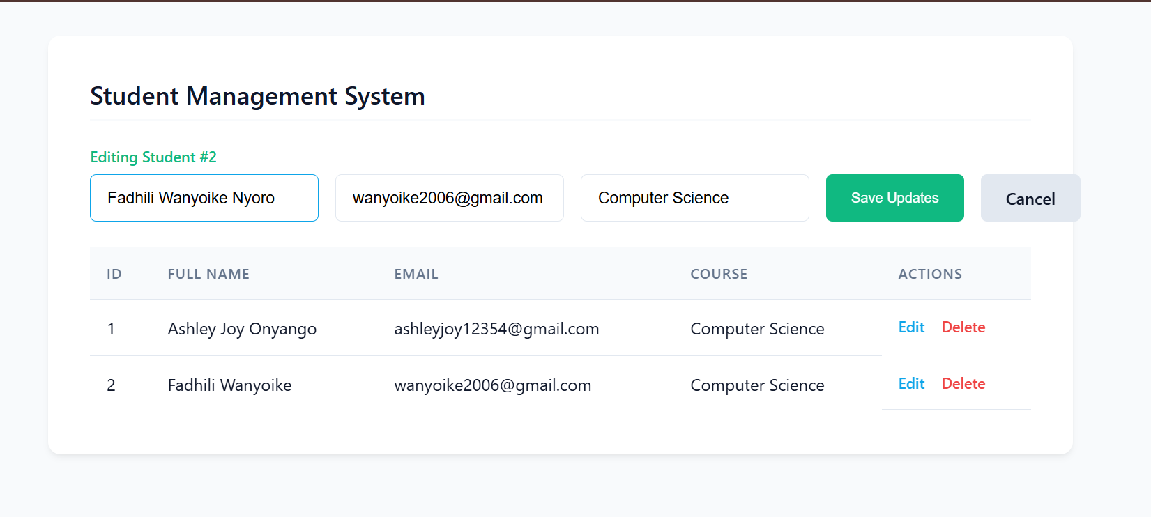
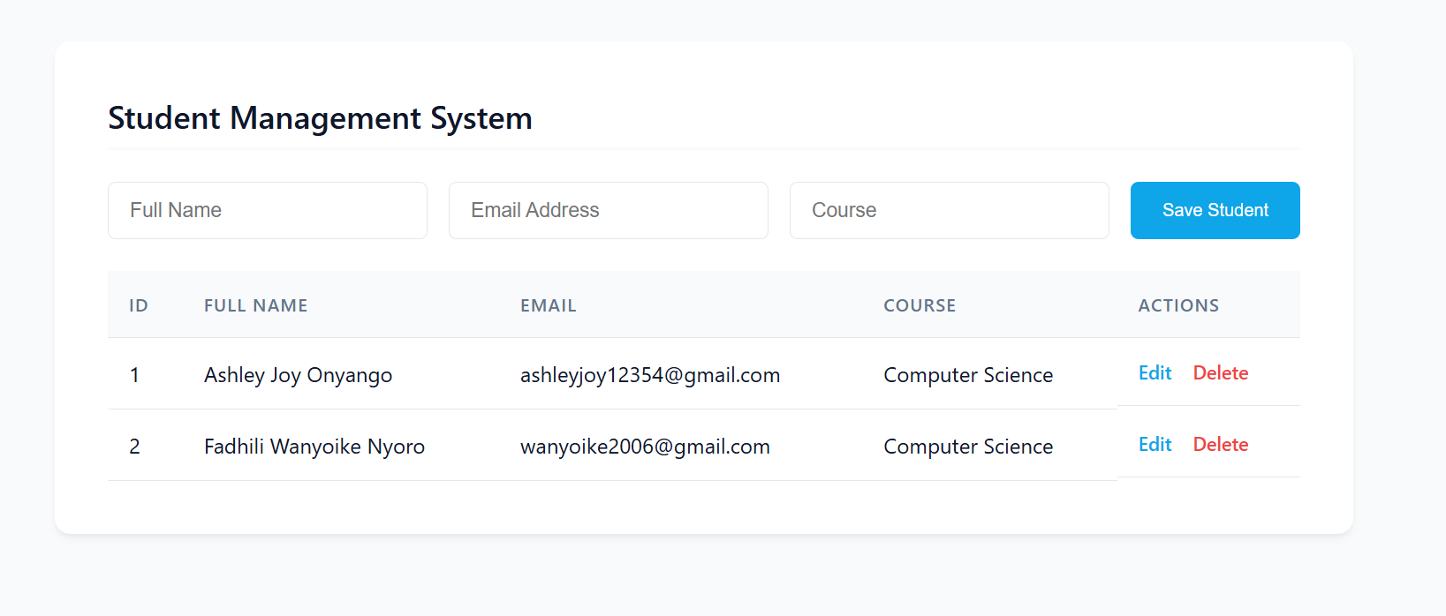
Figure 36: Student Management Portal Update


Figure 37: "Fadhili Wanyoike Nyoro" Deleted

Practical Task 2: Library Book Management System
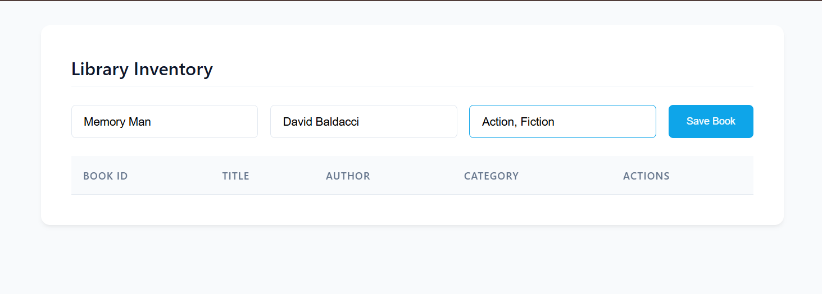
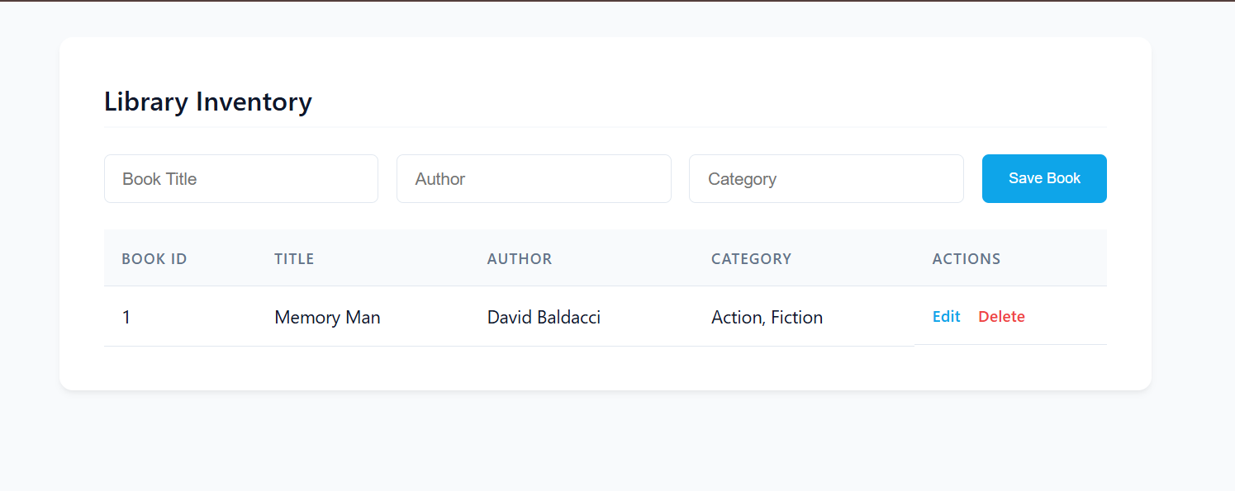
Figure 38: Library Management System Create & Read
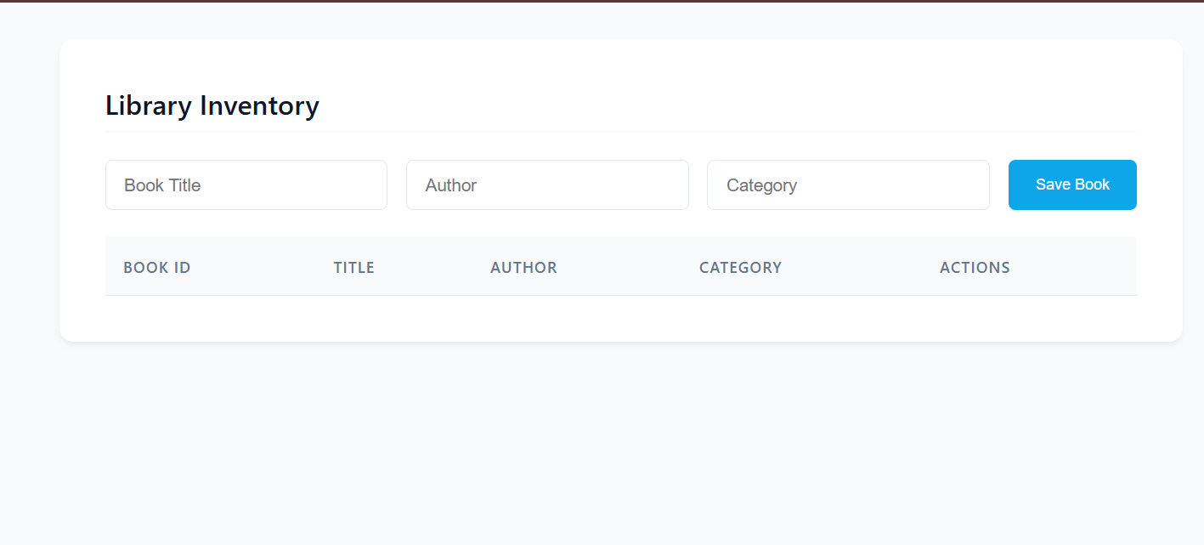
Figure 39: "Memory Man" Deleted
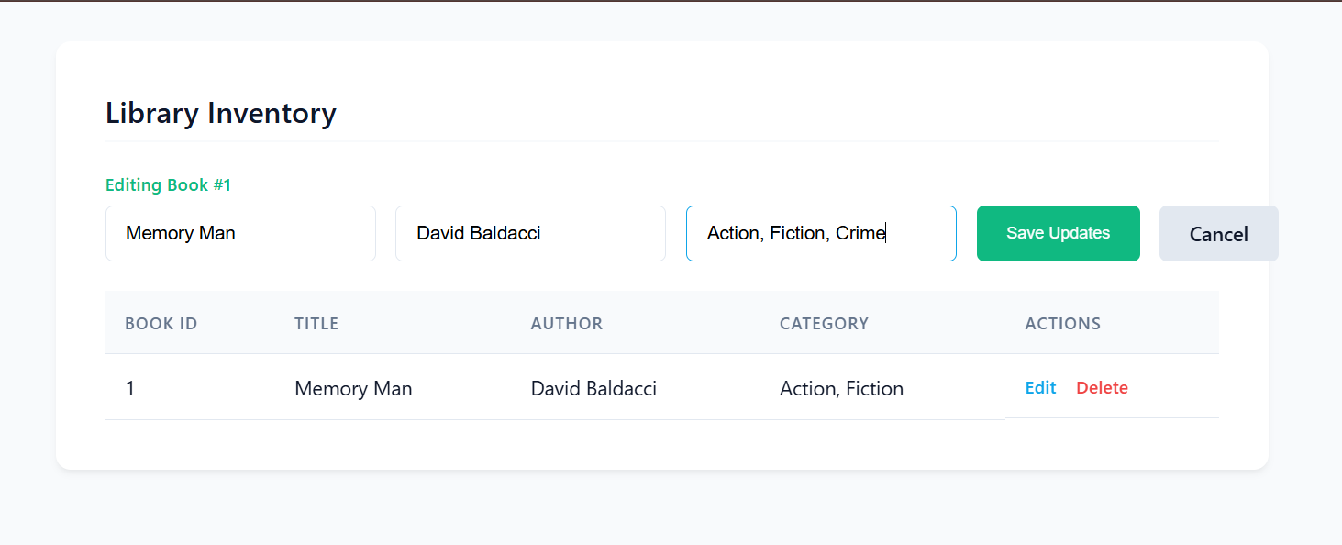
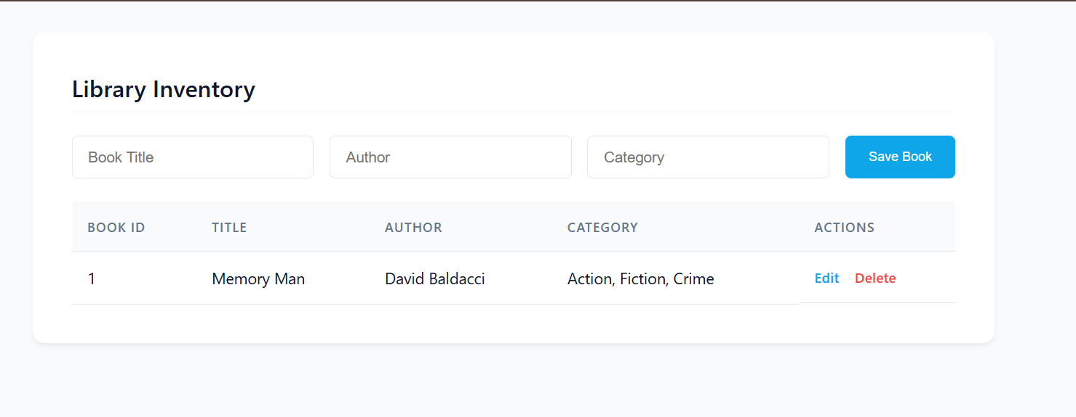
Figure 40: Library Management System Update
I created a Library Book Management System designed to handle inventory tracking. This involved setting up a database schema specifically for books, including fields for a unique Book ID, Title, Author, and Category. Similar to the student system, I fully implemented CRUD functionality, providing a seamless interface to register new books into the system, display the current inventory, modify book details, and remove books from the catalog.

Practical Task 3 (Challenge Task): Employee Records Management System
I built a robust Employee Records Management System that goes beyond basic CRUD operations by incorporating several advanced bonus features. Alongside the core ability to register, view, update, and delete employee details, I integrated a secure session-based user login system that protects the dashboard from unauthorized access. Furthermore, I enhanced the application's usability by implementing backend and frontend form validation to ensure data integrity, adding a functional search bar to easily locate employees by name or department with a responsive design.
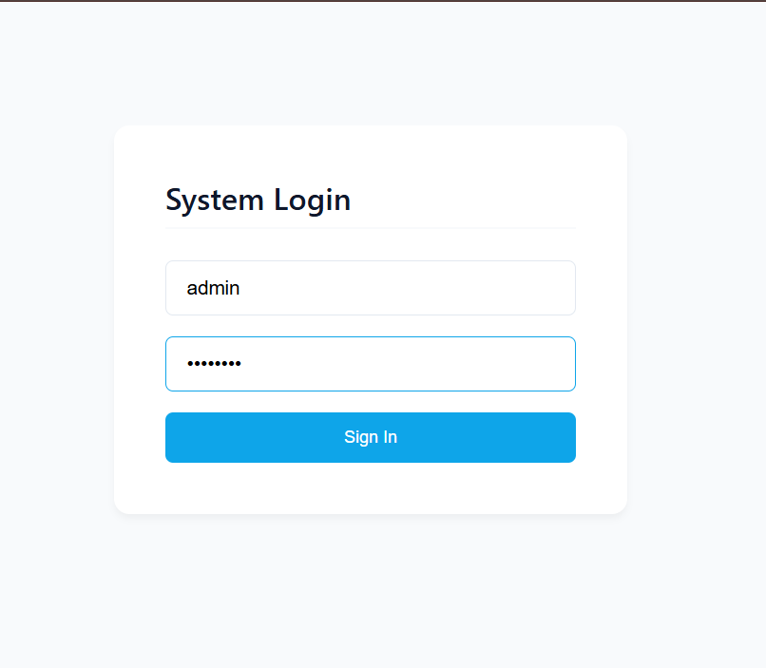
Figure 41:Employee Records Management System Login
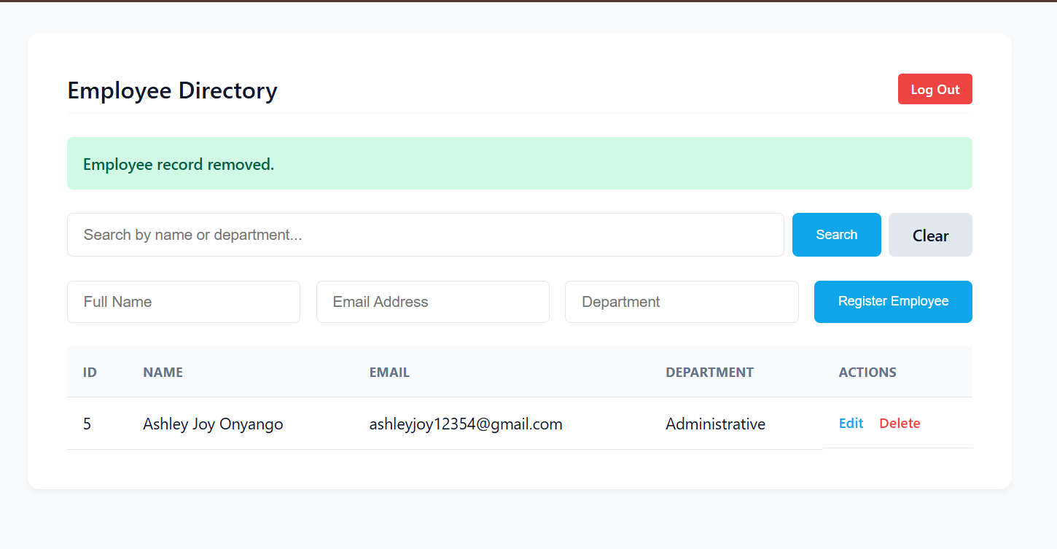
Figure 42: "Fadhili Wanyoike" Deleted

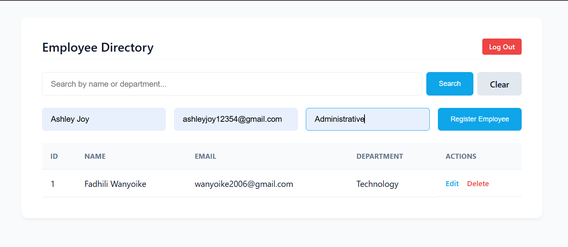
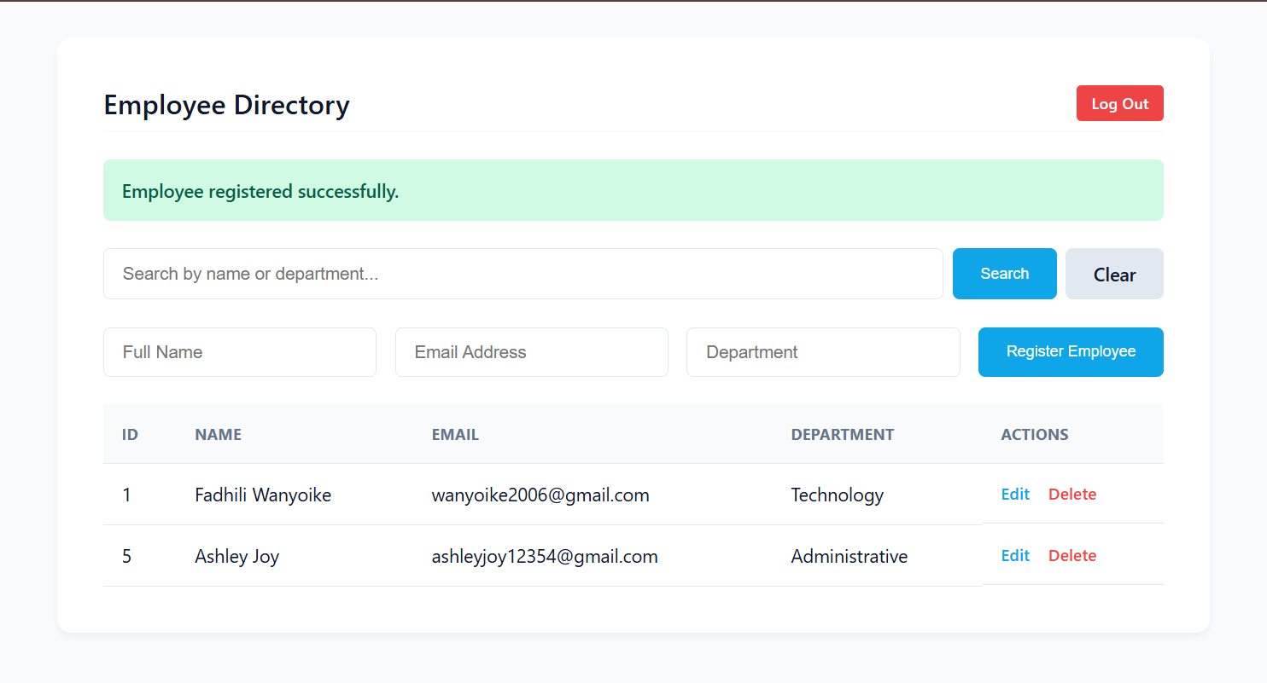
Figure 43: Employee Records Management System Create & Read

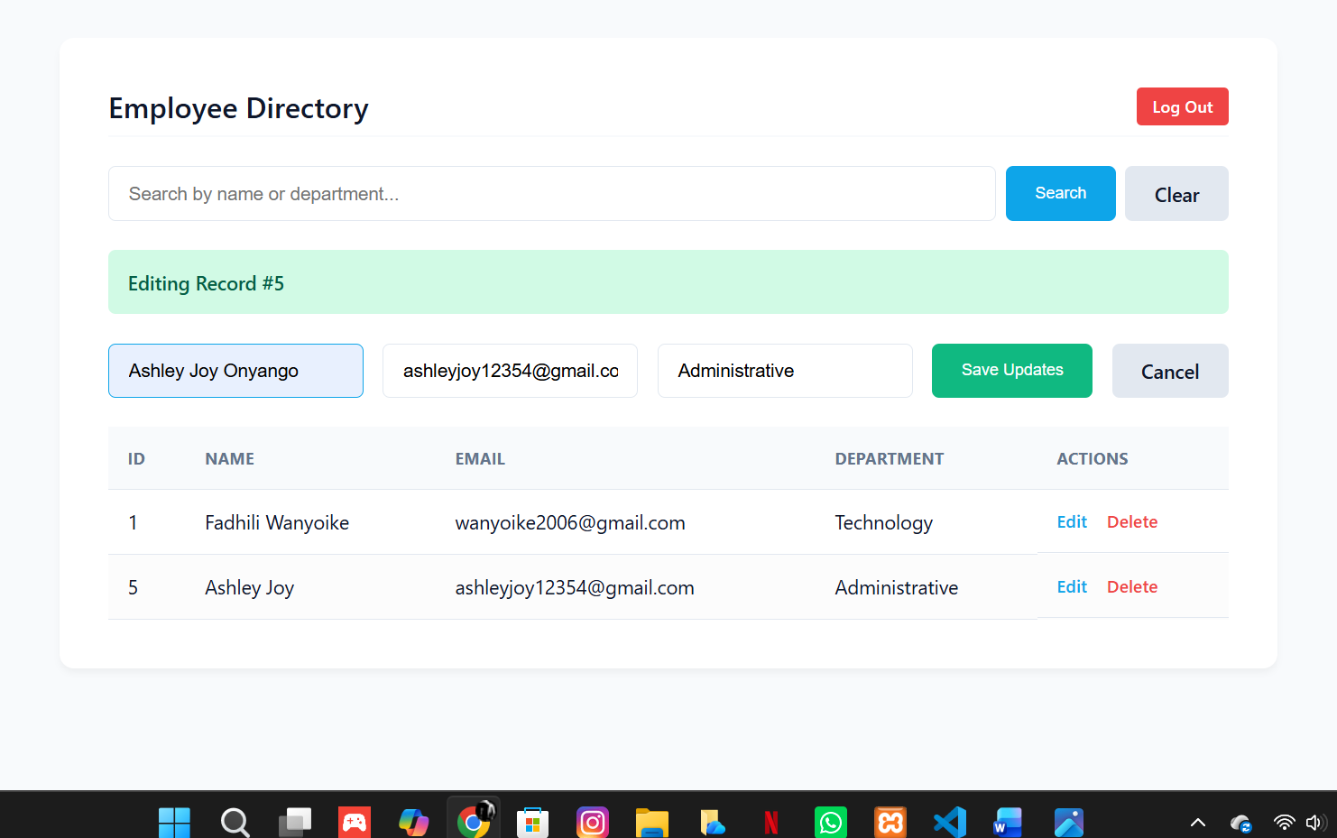
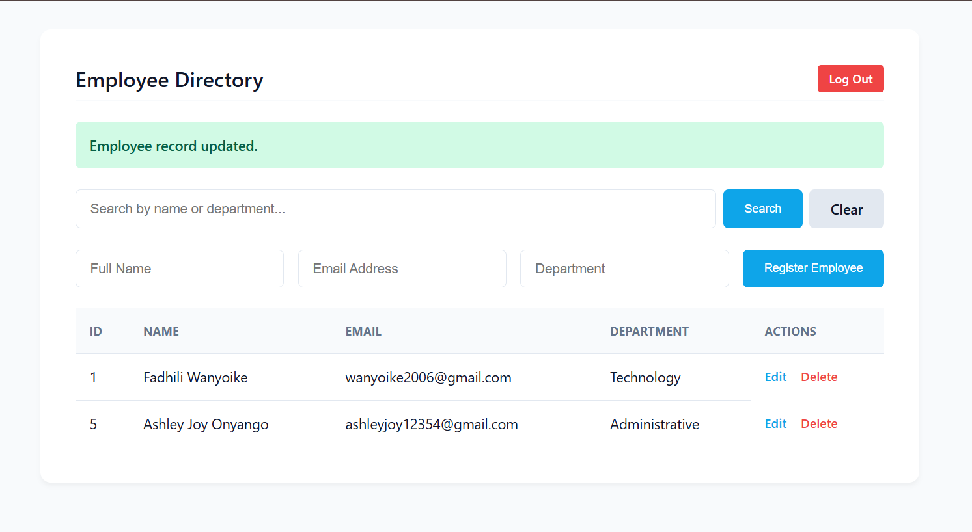
Figure 44: Employee Records Management System

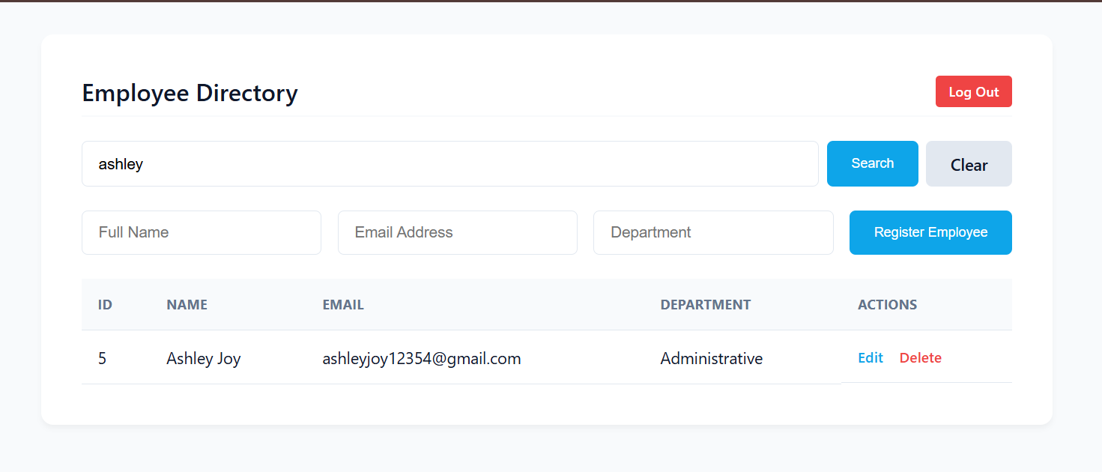
Figure 45: Search Employee

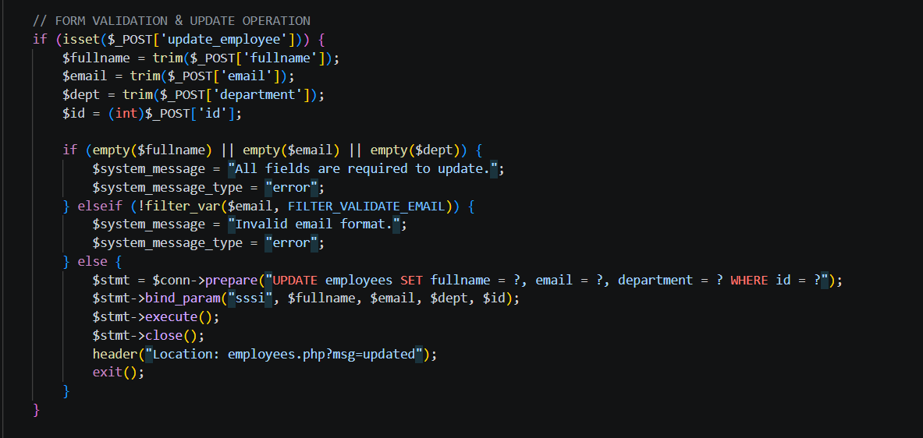
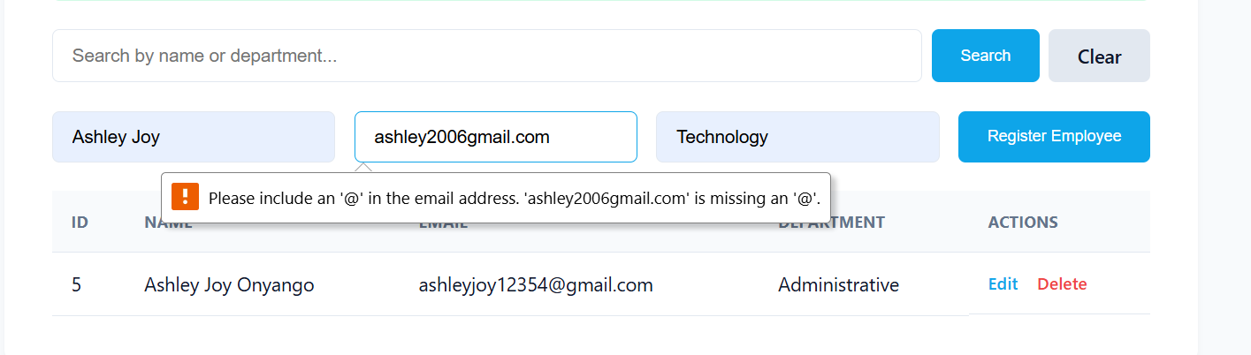
Figure 46: Form Validation

